Below are the steps for Empulse manual entry

1. Go to talent page : <https://talent.capgemini.com/in/>
2. Click on AMIS tab

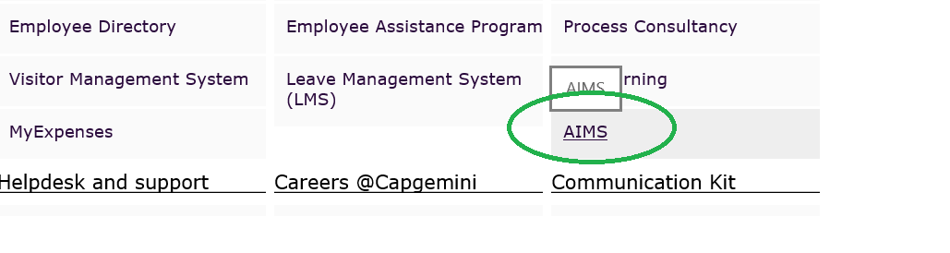

1. Go to people and click on empulse

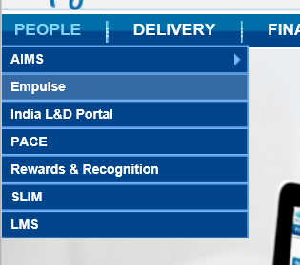

1. Click on Attendance tab 🡪 request 🡪 Self-manual attendance

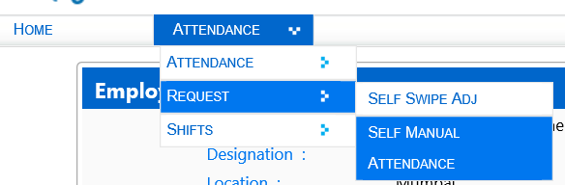

1. Click on add button

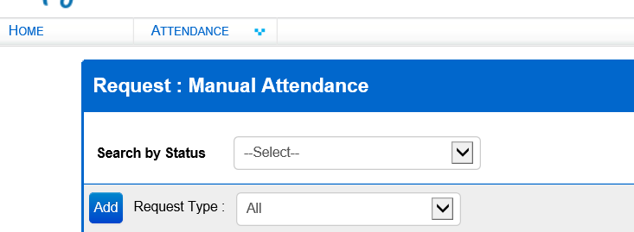

1. Enter the working date(s), working shift and time after that save

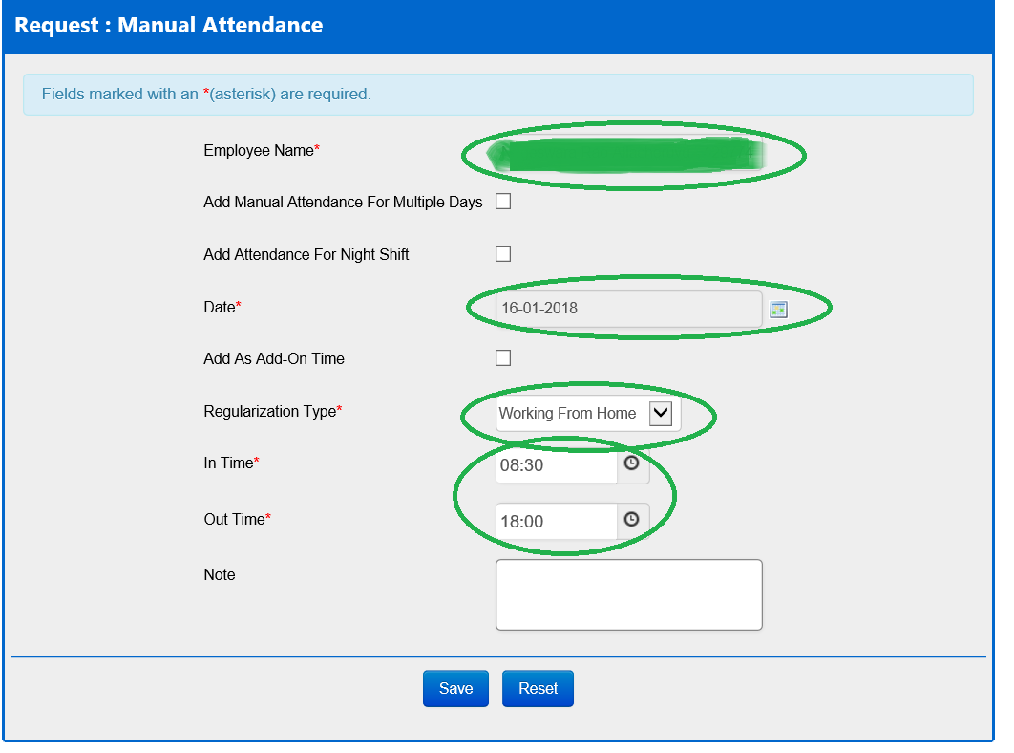

1. You will get email notification after that your manager will approve on it.

